Customer Shopping Behavior Analysis
Python, PostgreSQL, and Power BI

1. Project overview
This project analyzes 3,900 customer purchases, totaling $233,081 in revenue, to understand what drives spending and loyalty. The analysis covers three stages: data cleaning and feature engineering in Python, business questions answered with SQL in PostgreSQL, and an interactive Power BI dashboard. The report ends with recommendations based on the findings.

2. Business problem
A retail company wants to understand its customers' shopping behavior in order to improve sales, engagement, and loyalty. The questions behind this project are:
- Who are the customers, and how loyal are they?
- Which categories and products drive revenue?
- Do subscriptions, discounts, or shipping choices affect how much customers spend?
- Do age or gender make a difference?

3. Dataset summary
The dataset has 3,900 purchase records and 18 columns, grouped into three types:
- Customer demographics: age, gender, location, subscription status
- Purchase details: item purchased, category, purchase amount, season, size, color
- Shopping behavior: discount applied, promo code used, previous purchases, purchase frequency, review rating, shipping type, payment method
Only the review rating column had missing values (37 of 3,900 rows, about 1%). The dataset has no date column, so it can't be used to look at trends over time.

4. Exploratory data analysis using Python
The data was prepared and cleaned in Python before any analysis:
- Data loading: imported the dataset into a pandas DataFrame with pd.read_csv().
- Initial exploration: used df.head(), df.info() and df.describe() to check the structure, data types and summary statistics (3,900 rows, 18 columns)
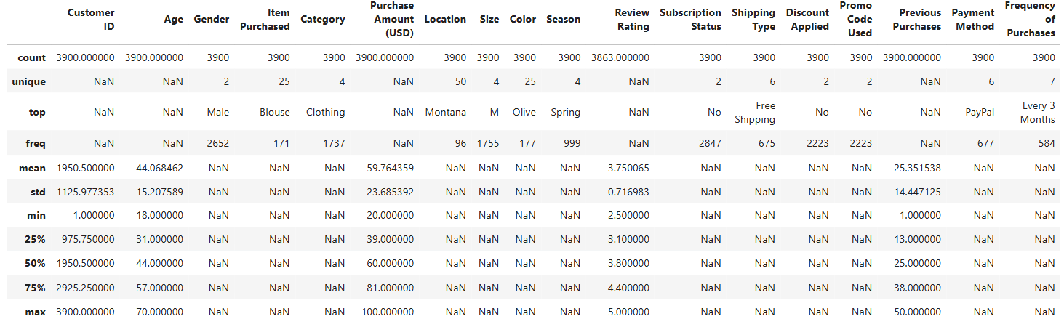
Figure 1: Summary statistics for all 18 columns
- Missing data handling: isnull().sum() found 37 missing values in Review Rating. I imputed them with the median rating of each product category using groupby('Category') and transform(), then re-ran isnull().sum() to confirm no nulls remained.
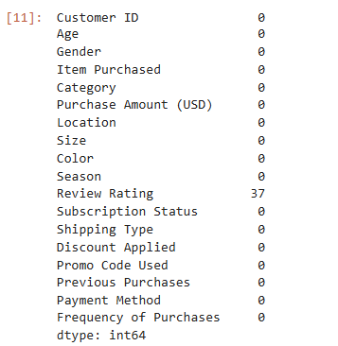
Figure 2: Missing values per column before imputation
- Column standardization: renamed the columns to snake_case (and purchase_amount_(usd) to purchase_amount) for readability and easier SQL querying.

- Feature engineering:
  - Created the age_group column by binning age into four groups with pd.qcut().
  - Created the purchase_frequency_days column by mapping frequency_of_purchases (such as Weekly, Monthly, Quarterly) to a number of days.
- Data consistency check: verified that discount_applied and promo_code_used matched in every row, then dropped promo_code_used as redundant.
- Database integration: connected the notebook to PostgreSQL using SQLAlchemy and psycopg2, and loaded the cleaned DataFrame into a table named customer with df.to_sql() for the SQL analysis.

5. Data analysis using SQL (business transactions)
I ran structured queries in PostgreSQL to answer 10 business questions:
- Revenue by gender: compared total revenue generated by male and female customers.
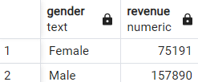
Male customers bring in about 68% of revenue ($157,890 vs $75,191), roughly twice as much as female customers.
- High-spending discount users: identified customers who used a discount but still spent more than the average purchase amount.
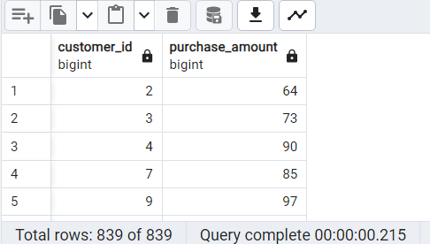

839 customers (about 22%) used a discount and still spent above the $59.76 average, so discounts don't stop them from spending.
- Top 5 products by rating: found the products with the highest average review rating.
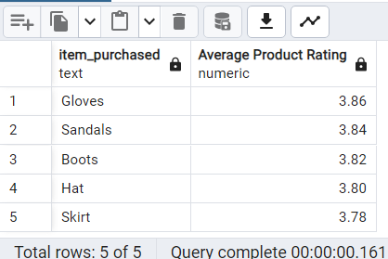
Gloves, Sandals and Boots lead at 3.86 to 3.82, but all five are within 0.08 of each other, so ratings are very similar across products.
- Shipping type comparison: compared average purchase amounts between Standard and Express shipping.
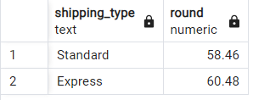
Express averages $60.48 and Standard $58.46, a gap of only about $2.
- Subscribers vs. non-subscribers: compared average spend and total revenue by subscription status.
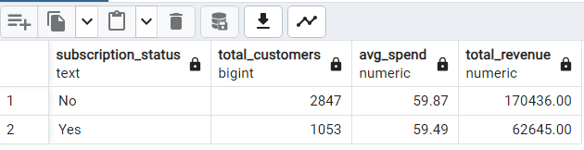
Subscribers spend about the same as non-subscribers ($59.49 vs $59.87), so subscribing isn't increasing spending.
- Discount-dependent products: identified the 5 products with the highest share of discounted purchases.
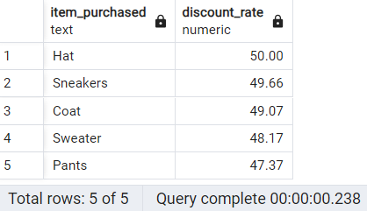
Hats and sneakers are discounted most often (about 50%), but all five products are close to half, so no single product depends heavily on discounts.
Customer segmentation: classified customers as New (1 previous purchase), Returning (2 to 10) or Loyal (11 or more).
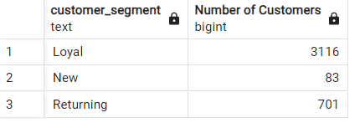
80% of customers (3,116) are Loyal and only 83 are New, so attracting new customers is the weak spot.
- Top 3 products per category: listed the most purchased products in each category.
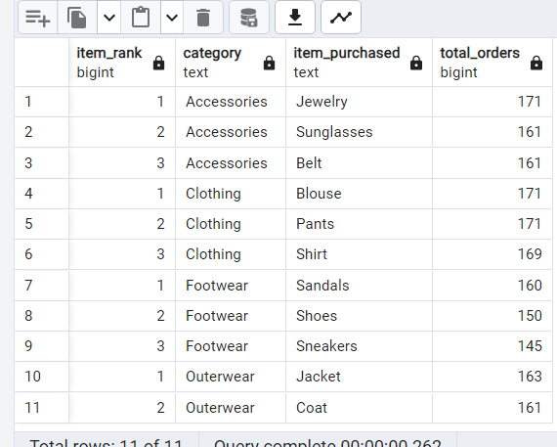
Jewelry, Blouse, Pants, Sandals and Jacket lead their categories, and the top products are close (145 to 171 orders), so no single item dominates.
- Repeat buyers and subscriptions: compared the subscription rate of customers with more than 5 previous purchases against everyone else.
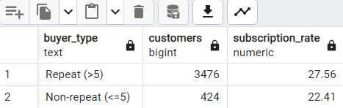
27.56% of repeat buyers subscribe vs 22.41% of other customers, so repeat buyers are only slightly more likely to subscribe.
Note: the non-repeat group is much smaller (424 customers vs 3,476 repeat buyers), so this comparison should be read with caution.
- Revenue by age group: calculated revenue, customer count and average spend for each age group.
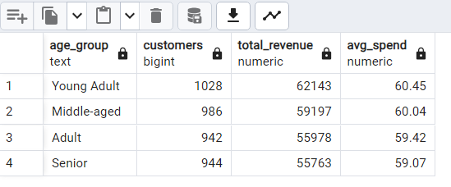
Young Adults bring in the most ($62,143), but average spend is nearly the same in every group ($59.07 to $60.45), so age isn't a strong driver of spending.

6. Dashboard in Power BI
Finally, I built an interactive one-page dashboard in Power BI, connected to the PostgreSQL customer table, to present the insights visually.
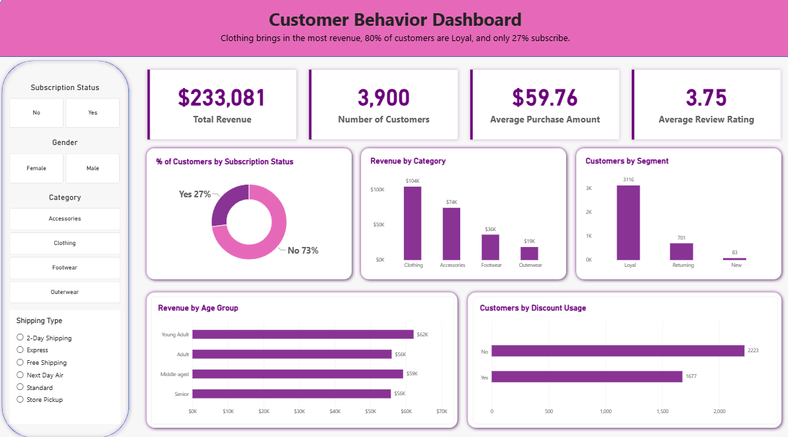
Figure 3: Customer Behavior Dashboard

The dashboard includes:
- KPI cards: Total Revenue ($233,081), Number of Customers (3,900), Average Purchase Amount ($59.76) and Average Review Rating (3.75).
- Subscription status: a donut chart showing that 27% of customers subscribe and 73% do not.
- Revenue by category: Clothing is the highest ($104K), followed by Accessories ($74K), Footwear ($36K) and Outerwear ($19K).
- Customers by segment: 3,116 Loyal, 701 Returning and 83 New customers (New = 1 previous purchase, Returning = 2 to 10, Loyal = 11 or more).
- Revenue by age group: the four age groups are close, from $56K to $62K, with Young Adults highest.
- Customers by discount usage: 2,223 customers without a discount and 1,677 with one.
- Interactive filters: slicers for subscription status, gender, category and shipping type let viewers explore the data.

7. Business recommendations
Summary. Average spend barely changes across subscription status ($59.49 vs $59.87), age group ($59.07 to $60.45) or shipping type ($58.46 vs $60.48). No single group stands out as a big spender, so growth is more likely to come from the size of the customer base and how it's served than from targeting one segment. The recommendations below follow from that.
1. Grow the New customer base.
Evidence: 3,116 customers are Loyal, 701 are Returning and only 83 are New (Q7). Segments are defined by previous purchases: New = 1, Returning = 2 to 10, Loyal = 11 or more.
Recommendation: test an acquisition campaign, such as an incentive on a first purchase.
How to measure: the number of New customers over time.
2. Rethink what a subscription offers.
Evidence: only 27% of customers subscribe, and subscribers spend about the same as non-subscribers ($59.49 vs $59.87) (Q5). Repeat buyers are only slightly more likely to subscribe (27.56% vs 22.41%) (Q9).
Recommendation: since subscribing isn't linked to higher spend, test subscriber benefits designed to encourage larger purchases.
How to measure: subscribers' average spend compared with non-subscribers' after the change.
3. Test discounts before extending them.
Evidence: 43% of purchases used a discount (1,677 of 3,900). The five most-discounted products, led by Hat (50.00%) and Sneakers (49.66%), are all close to half (Q6). 839 customers spent above the average even with a discount (Q2).
Recommendation: run a controlled test that reduces the discount on one or two heavily discounted products and check whether sales hold.
How to measure: units sold and revenue per product, with and without the discount.
4. Build on the products and categories that already lead.
Evidence: Clothing brings in $104K of the $233K total, and Jewelry, Blouse and Pants lead their categories at 171 orders each (Q8). Outerwear is the lowest-revenue category at $19K.
Recommendation: feature the top-selling products in campaigns and look into what holds Outerwear back.
How to measure: revenue by category over time.
5. Segment customers by behavior, not age.
Evidence: all four age groups bring in between $56K and $62K, with average spend within $1.38 of each other (Q10).
Recommendation: use behavior-based segments, such as customer segment (New, Returning, Loyal) and subscription status, instead of age.
How to measure: compare the results of a campaign aimed at a behavioral segment with one aimed at an age group.
Where I'd start. Recommendation 1, because the gap between Loyal (3,116) and New (83) customers is the is the largest imbalance in the data.

8. Limitations
- No date information. The dataset has a Season column but no purchase dates, so the analysis can't show trends over time, growth, or whether customers are returning more often.
- Segment cutoffs are my choice. New (1 previous purchase), Returning (2 to 10) and Loyal (11 or more) are definitions I set. previous_purchases ranges from 1 to 50 with a median of 25, so most customers (80%) land in Loyal under these cutoffs. Different cutoffs would change the segment sizes, though not the underlying data.
- Unequal group sizes in Q9. The subscription comparison is between 3,476 repeat buyers and 424 other customers, so the smaller group gives a less stable rate.
- No cost or price data. The data has a purchase amount but no product costs or original prices, and it doesn't say whether that amount is before or after the discount. The analysis therefore can't show whether discounts reduce profit, so the discount recommendation is a suggestion to test, not a conclusion.
- Patterns, not causes. The analysis describes what is related to what in this dataset. It can't show that subscriptions, discounts or shipping choices cause any change in spending. The recommendations are meant to be tested before being rolled out.
- One dataset. The findings describe these 3,900 purchases only and may not apply to other customers or time periods.

